Broken Stars

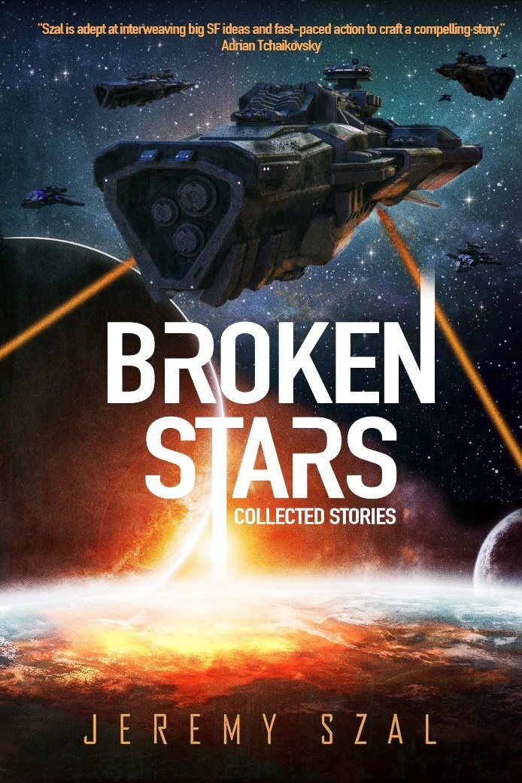 | Author: Jeremy Szal  Target genre/audience: adult speculative fiction  ISBN (print): 9798232335069  ISBN (ebook): 9798232375317  Format: Paperback/ebook  Publication Date: October 2025 (revised edition)  Pages: 330  List Price: $19.99 (USD)/$29.99 (AUD)  This title is distributed through Ingram and is available in all major territories and retailers, including Amazon, Barnes and Nobles, Kobo, Apple books, etc.  Contact info: jeremyszal@gmail.com
About the Book

Broken Stars combines previously published short stories and novelettes with new and exciting tales, ranging from space opera to military SF to science-fantasy and everything in-between.

Tales of broken heroes fighting for hope in dark worlds, full of aliens and outcasts, drug dealers and bounty hunters, mercenaries and soldiers. Tales of far-flung worlds where the lines between machine and human become blurred, the humanity of monsters is explored, and victory always comes with a heavy price. In these eighteen stories of far-flung worlds, violence explodes, betrayals abound, and no one is safe.
A smuggler for alien drugs is thrust into a high stakes of subterfuge and interstellar drug trades, only to find herself out of her depth.
Yharv, a mercenary, must escort the King through a besieged city and see him crowned. The only problem is, Yharv isn’t human, and neither is the king, and nonhumans usually end up dead in a gutter. And luck has never been on Yharv’s side.
An alien and a human fight to liberate a planet where aliens are treated as second-class citizens. But freedom comes at a steep price.
A kidnapped warrior discovers her memories may not be her own, and she may be on the wrong side of her war.
And many more . . .

For fans of Pierce Brown, Adrian Tchaivkovsky, and James S. A. Corey

Praise for Jeremy Szal

'Szal is adept at interweaving big SF ideas and fast-paced action to craft a compelling story' - Adrian Tchaikovsky, author of CHILDREN OF TIME

“A high-power augmented SF adventure that will keep you reading!” - Garth Nix, New York Times best-selling author of SABRIEL

“Sci-fi with an edge. You'll want two things when you're finished this book: a glass of gin and a sequel”―Nicholas Eames, author of KINGS OF THE WYLD

“This is what 21st century Sci-Fi ought to be” - Miles Cameron, author of ARTIFACT SPACE

“This book will kick you in the nuts as you’re lying on the floor.” – Richard Swan, Sunday times best-selling author of THE JUSTICE OF KINGS

Praise for Broken Stars

“Rendered in immersive prose, Broken Stars glitters with creative SF ideas, compelling characters, and exciting plots that always tackle interesting themes while centering their bleeding, human hearts.” - Wole Talabi, Hugo, Nebula and Locus-award nominated author of SHIGIDI

“Broken Stars is a very powerful, varied and impressive collection of short tales reminding us that Szal is a very skilled writer in the genre today.” – Runalong the Shelves

“A fabulous collection of stories that will delight any science fiction fan.” – Fantasy Book Nerd

“Dark and very human, this author will take you to well-thought out places and conflicts that leave an indelible impression” – Abyss & Apex Magazine

“Szal’s imagination is as wide and impressive as the galaxy.” – Jackson Ford, best-selling author of The Girl Who Could Move Sh*t With Her Mind

About Jeremy Szal

Jeremy Szal was born in 1995 and was raised by wild dingoes, which should explain a lot. He writes epic fantasy and dark space opera of a character-driven, morally grey nature. His main series is the Common trilogy from Gollancz/Hachette, which includes STORMBLOOD, BLINDSPACE, and WOLFSKIN, about a drug harvested from alien DNA that makes users permanently addicted to adrenaline and aggression.

He’s the author of over fifty short stories, translated into fifteen languages, many of which appear in his short fiction collection BROKEN STARS. He was the editor for the Hugo-winning StarShipSofa until 2020 and has a BA in Film Studies and Creative Writing from UNSW.

He carves out a living in Sydney, Australia with his family, where he loves watching weird movies, eating Japanese food, exploring cities, learning languages, cold weather and dark humour. Find him at https://jeremyszal.substack.com/ or @JeremySzal

For rights inquiries, please contact:

- John Jarrold (primary agent)
The John Jarrold Literary Agency
Flat 2, Old Grammar School, High Street
Rye, East Sussex TN31 7JF
j.jarrold@btinternet.com
- Julie Kane-Ritsch (Film/TV rights)
The Gotham Group
9255 Sunset Boulevard, Suite 515,
Los Angeles, CA 90069
(310) 285-000
rightscoordinators@gotham-group.com

- Gray Tan – Asian territories subagent (China, Japan, Korean, Taiwan, Vietnam, etc)
The Grayhawk Agency
grayhawk@grayhawk-agency.com

